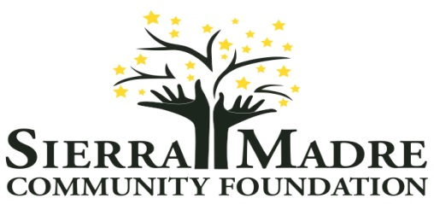
P.O. Box 716
Sierra Madre, CA 91025
www.sierramadrefoundation.org
sierramadrefoundation@gmail.com

SMCF GRANT APPLICATION

Requestor Information

Date of Request:
Name: | Position: | Organization:
Name: | Position: | Organization website (if applicable):
Address: | City: | ZIP Code:
Work Phone: | Cell Phone: | Home Phone:
Email Address(es):

Grant Request

1 | Amount Requested: $
2 | If this grant request is approved, who should the check be made payable to?
3 | Description of Program/Project: Include how this project and, by extension, the grant will serve the community of Sierra Madre.
4 | Project Timeline for use of the requested funds:
5 | Project Budget: (Highlight where SMCF funds will be applied)
6 | Target Population(s) in Sierra Madre that will be served:
7 | Desired outcome and plans for achieving it:
8 | List how the completion and/or success of the project will be measured:
9 | Statement regarding why a SMCF Grant is integral to the success of the project.: (List other sources of support committed thus far or other support being sought, if applicable)
10 | Brief Organizational Background:(Include mission, current priorities, and community initiatives)
11 | Organization’s Current Funding Source(s) and Financial Structure: (i.e. 501(c)(3) nonprofit, public entity, volunteer group, committee, etc.).
12 | Attach any supporting documents, if applicable:

Grant applications are reviewed and considered at Sierra Madre Community Foundation Board (SMCF) Meetings, which are held on the 3rd Tuesday of the months of January, March, May, July, September, & November. Completed Grant Applications are due by the 5th of January, March, May, July, September, or November in order to be considered at that month’s SMCF Board Meeting.

Completed grant applications can be submitted as follows:

- Emailed: sierramadrefoundation@gmail.com

- US Mail to: Sierra Madre Community Foundation, P.O. Box 716, Sierra Madre, CA 91025

For more information, please visit: www.sierramadrefoundation.org or call SMCF Grants Chairperson, Sue Spears, at (626) 355-0948.

